The population value was computed for 15 steps using the logistic equation. The resulting values were plotted to visualize the evolution of the population over time.
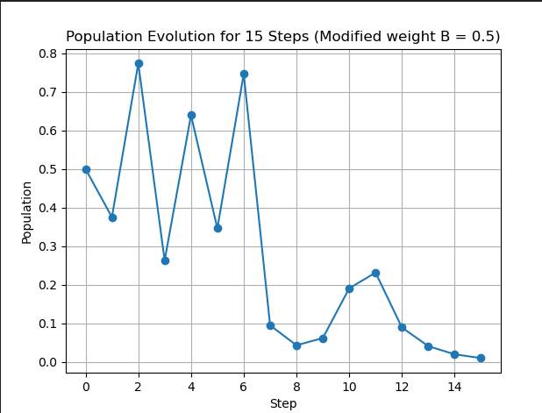

The graph shows how the population changes depending on which state appears in the sequence. When the system enters state C, the growth factor is relatively large and the population may increase. When the system enters state A, the growth factor produces moderate growth.
However, when the system enters state B, the growth factor is 0.5, which is less than 1. In the logistic model, values of r<1 cause the population to decrease toward zero.
During the simulation, the population fluctuates depending on the sequence of states produced by the Markov machine. States with larger growth factors can temporarily increase the population, but visits to state B significantly reduce it.
Because the Markov machine may enter state B multiple times, the population tends to decrease over time.
After simulating the system for 15 steps, the population becomes very small and tends toward zero. This occurs because the growth factor associated with state B (r = 0.5) reduces the population each time it appears in the sequence.
Therefore, the population does not survive after 15 steps, as it gradually approaches extinction due to repeated decreases caused by state B.

